**Lab 4: Factorial**

The aim of this lab is to allow you to use both flow of control and iteration structures in JavaScript. To do this we will be writing a short program to calculate the factorial of a number.

**Calculate the Factorial of a number**

You should write a program that can find the factorial of any given number.

For example, find the factorial of the number 5 (often written as 5!) which is 1 * 2 * 3 * 4 *5 and equals 120.

The factorial is not defined for negative numbers and the factorial of Zero is 1; that is 0! = 1.

**Step 1: Create a new file**

Create a new file for your factorial calculation. Remember you can do this using File->NewFile.

Next save your file using File->Save As… - save your file into your coursework directory and call it factorial.js, for example:

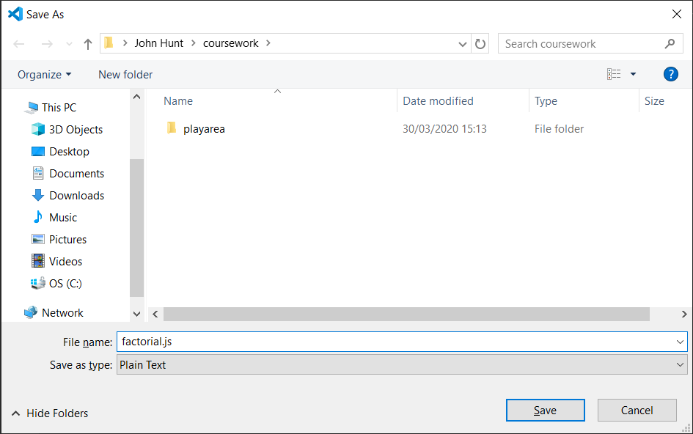

**Step 2: Add Initial Code**

Your program should define a number at the start of the program for which the factorial will be calculated, for example:

console.log("Starting factorial calculation program")

**let** number = 5;

console.log('Calculating the factorial for', number)

This is shown below:

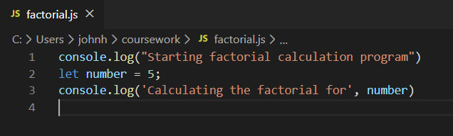

Save the file with the updated contents and then run it as you did in the earlier labs. For example, use the right mouse menu to select Run Code.

As before we are testing the program as we go along to make sure everything works. The output this time is:

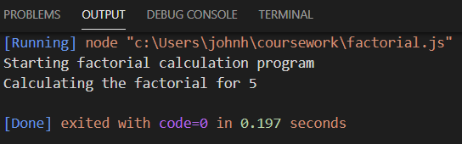

**Step 3: Add logic to perform calculations**

You should determine

1. If the number is less than Zero return with an appropriate message.
2. Check to see if the number is Zero – if it is then the answer is 1 – print this out.
3. Otherwise use a loop to generate the result and print it out.

The conditional aspect of the above program can be handled using an if statement (ideally with else if elements).

For example

if (number < 0) {

console.log('Factorial is not defined for negative numbers')

} else if (number == 0) {

console.log("0! factorial is 1");

} else {

// write your code here

}

The current state of the program is now:

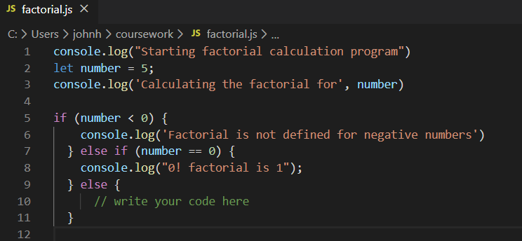

You should try to run this version to check that it does not contain any errors. You could try changing the value assigned to number to be -1 and 0 to check that each of the log statements associated with these conditions works correctly.

**Step 4: Add factorial calculation**

Inside the last else { } block of code you should now replace the *// write your code* here comment with a for loop.

The for loop will need to loop an appropriate number of times. For example:

let factorial = 1;

for (let i = 1; i <= number; i++) {

factorial = factorial * i;

}

console.log(number + "! factorial is", factorial);

The final program is shown below:

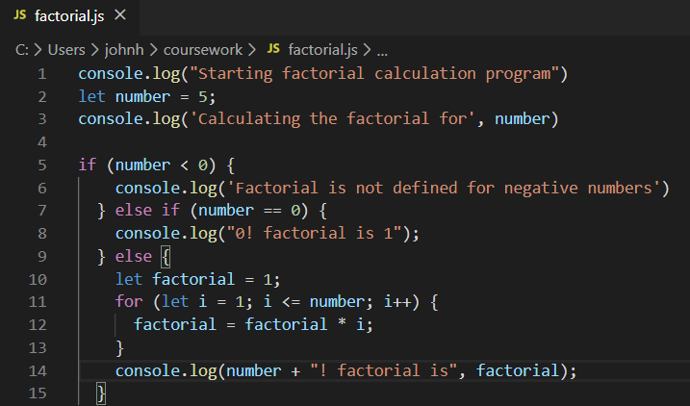

The output from the sample solution is:

Starting factorial calculation program

Calculating the factorial for 5

5! factorial is 120

Note the use of the ‘+’ operator in the last console.log() function call. This is acting as a concatenation operator here by combining the numbers with the string in the middle. It does this as long as at least one of its operands is a string. Otherwise it will do numerical addition.